Employment Application Form
Date:__________________
Name:_______________________________________________________________________________
Last First Middle

Present Address:_______________________________________________________________________
Number Street City State Zip

Home Phone # (___)_________________
Mobile Phone # (___)________________
Social Security # ______-____-_______
Date of birth: /______/________

Are you 18 years or older? YES / NO
Are you legally entitled to work in the United States? YES / NO
Position Applying for__________________________________ Desired Salary $________________
Date you can start______________________
If yes, can you work overtime or be oncall? YES / NO
Do you have means of transportation? YES / NO What is it?_________________________
Have you ever been convicted of a crime? YES / NO
If YES, please explain: _______________________________________________________________________________________________________________________________________________________________________________________________________________________________________________________________

EDUCATION
High School
Name of School: ________________________________________________________________
Address, City, State: _____________________________________________________________
Number of years attended: _________________ Did you graduate? YES / NO Year:_______
Trade School
Name of School: ________________________________________________________________
Address, City, State: _____________________________________________________________
Number of years attended: _________________ Did you graduate? YES / NO Year:_______
College and Post Graduate
Name of School: ________________________________________________________________
Address, City, State: _____________________________________________________________
Number of years attended: _________________ Did you graduate? YES / NO Year:_______
What Degree?___________________________________

Use the space below to summarize any additional information necessary to describe your training or education that would be beneficial to our company.
_______________________________________________________________________________________________________________________________________________________________________________________________________________________________________________________________

Employment
Please list your work experience for the past five years beginning with your most recent employment. If you were self-employed, give a firm name.

*Employer Name: _______________________________ Telephone # (___)________________
Address, City, State:_____________________________________________________________
Position Held:__________________________________________________________________
Supervisor’s Name:______________________________________________________________
Reason for Leaving: _____________________________________________________________
Employment Dates: From:_____________________ To:________________________________
Pay or Salary Start: ___________________________ Final: _____________________________
*Employer Name: _______________________________ Telephone # (___)________________
Address, City, State:_____________________________________________________________
Position Held:__________________________________________________________________
Supervisor’s Name:______________________________________________________________
Reason for Leaving: _____________________________________________________________
Employment Dates: From:_____________________ To:________________________________
Pay or Salary Start: ___________________________ Final: _____________________________

*Employer Name: _______________________________ Telephone # (___)________________
Address, City, State:_____________________________________________________________
Position Held:__________________________________________________________________
Supervisor’s Name:______________________________________________________________
Reason for Leaving: _____________________________________________________________
Employment Dates: From:_____________________ To:________________________________
Pay or Salary Start: ___________________________ Final: _____________________________

Additional Qualifications
Use the space below to summarize any additional information necessary to describe your qualifications, skills, certifications, licenses or achievements that should be considered for this position.
____________________________________________________________________________________________________________________________________________________________________________________________________________________________________________________________________________________________________________________________________________________

May we contact your present or previous employer(s)? YES / NO
If no, why? ___________________________________________________________________________

Personal References
Please provide two or more references other than relatives or previous employers.
Name:_______________________________________________
How many years you have know them: _____________________
How you know them: ___________________________________
Telephone # (____)______________________

Name:_______________________________________________
How many years you have know them: _____________________
How you know them: ___________________________________
Telephone # (____)______________________

Name:_______________________________________________
How many years you have know them: _____________________
How you know them: ___________________________________
Telephone # (____)______________________

Authorization to Release Information
- I authorize Gervais Plumbing & Heating Inc. to obtain information about me from my previous employers, references, and schools.
- I authorize my previous employers, schools that I have attended and references to disclose such information about me as Gervais Plumbing & Heating Inc. requests.
- I authorize my previous employers to candidly disclose to Gervais Plumbing & Heating Inc. all facts and opinions concerning my work performance, cooperativeness and ability to get alone with others.
- All the information above is correct and filled out to the best of my ability

Date:________________________
Printed Name: ____________________________________________
Signature: ________________________________________________

Please review rate of pay at time of hire with employee and have the employee sign in the designated spot.
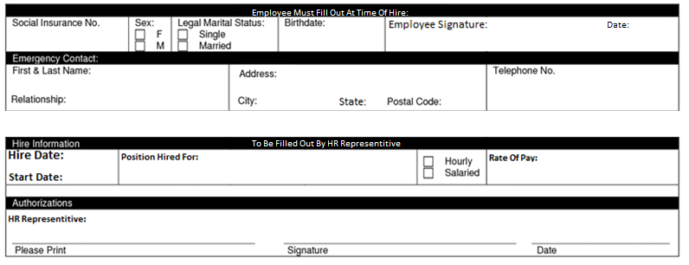

317 Southbridge Street
Auburn, MA 01501
508-617-2055
www.gervaisplumbing.com

